Java Coding Standards
Whatever members are defined a java which has a name is given a Naming standard by java.
- Class: According to java standards every class should start with the capital letters.
If the class contains two or more words then the each word within the class starting letter should be in capital.
This convention followed by java comes under pascle convention.
EX: StringBuffer, Demo, Sample, FileNotFoundExceptions

- Constructor: Same as class name.

- Interface: Follow the same convention as classes.
EX: Clonnable, Iterator
- Method: If the method contains single word then the starting letter should be in lower case,If a method contains more that one word then the starting letter on the second word onwards should be in uppercase.
This approach or convention is from camel case convention.
Ex: toString(), trim(), charAt()

- Variables: Follow the same convention as methods.

- Packages: Every package whatever we create should be in lowercase.
Ex: java.lang, java.io, java.util
- Constants: Every letter within the constant is represented in the upper case. If a constant contains two or more words then these words are connected with underscore character.

Packages
A Package can be defined as folder structure. A package contains collection of interfaces and classes. In java 8 total package supported are 14 where in the time is the new package. To create a package syntax is package packagename;
Ex: package packsample;
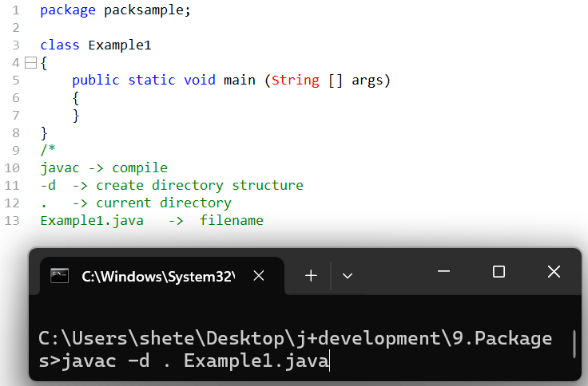

We can not only create single package but we can also create sub packages. A package name along with class name is called as fully qualified class name.

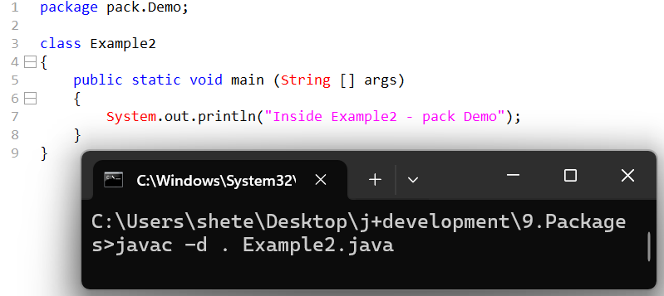

www.Tcs.com => package com.Tcs;
www.hsbc.tcs.com => package com.tcs.hsbc
www.banking.hsbc.tcs.com => package com.tcs.hsbc.banking
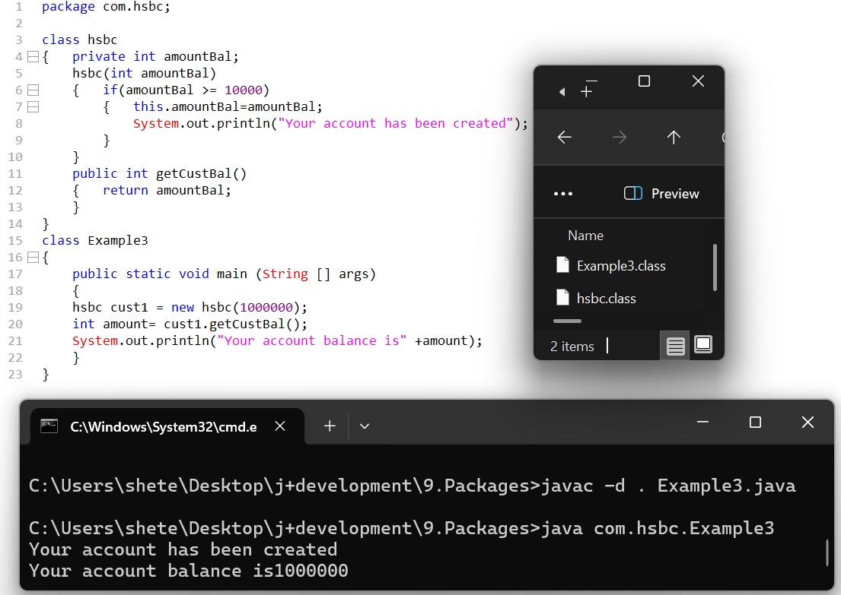

Access Modifier/Access specifiers
Access modifiers determine or specify how to access member within the same area or package as well as another area or another package.
In a package by default contains collections of classes
Access modifiers are of four types:
- Public
If a member is made public, we can access that member within the same class as well as another class within same package plus we can also access that member in another package.
Public access modifier is applicable at class level, variable, constructor and methods.
- Protected
If a member is made protected, we can access that member anywhere within the same class plus another class within same package as well as we can access that member in another package but only within the child class (means another package class should extend class of first class)
- Default
There is no keyword called as default access modifier If a member is not prefix with associated with default access modifier.
- Private
If a member is made private we can access that member within the same class but we cannot access that members in another class even it is within the same package as well as we cannot access that member in another package.

- Which is most visible access modifier?
Public access modifier
- Which is most secure modifier?
Private access modifier
- Least to most accessible
Private<<<Default<<<Protected<<<Public

Import keyword
- The import keyword is meant to import either single class or group of the classes
- There are two ways to use import keyword as mentioned below.
  - Import packagename.classname;
  - Import packagename;
Class name approach is a recommended approach.
To a access a class or any member within a package we need to make that member as public.
If a class is made public it does not need all it’s member by default will become public.
A java program allows a single package to be created Hence in a single java program we cannot create two or more packages.
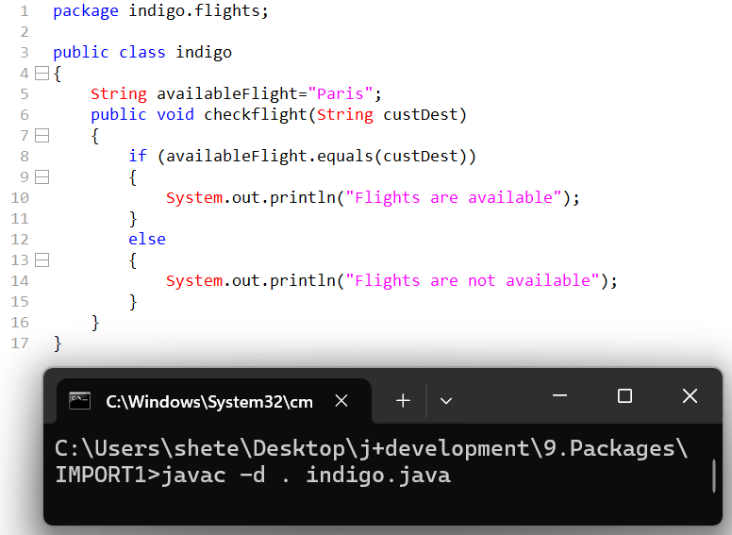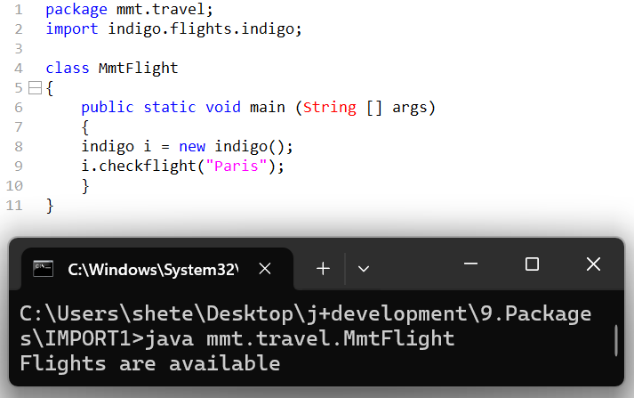

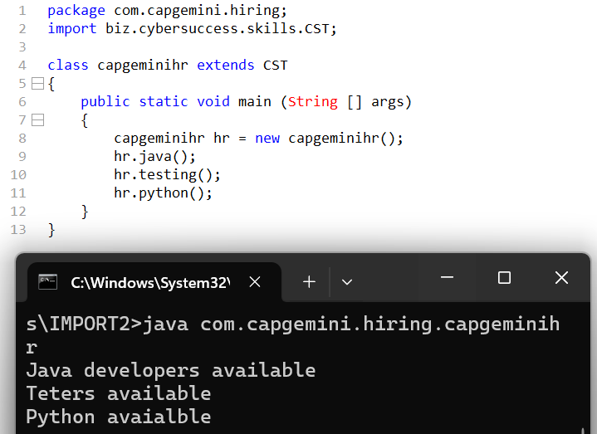

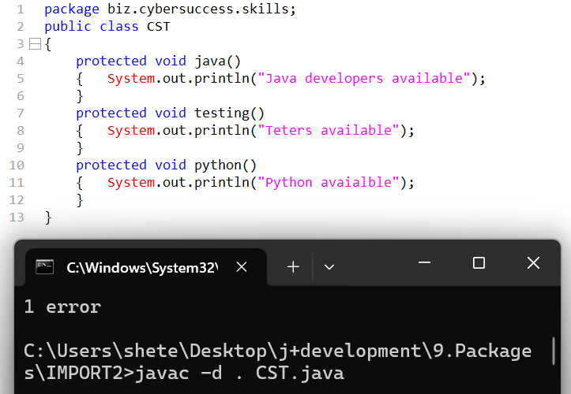

Wrapper Classes
Wrapper classes are used to convert primitive data in the form of objects.
What is need of Wrapper Classes
To increase security level of each data member we go for wrapper classes.
Note: Based on total primitive data types that many number of wrapper classes are supported by java.
Primitive Wrapper Class
byte Byte
short Short
int Integer
long Long
float Float
double Double
boolean Boolean
char Character
All wrapper classes comes under java.lang package
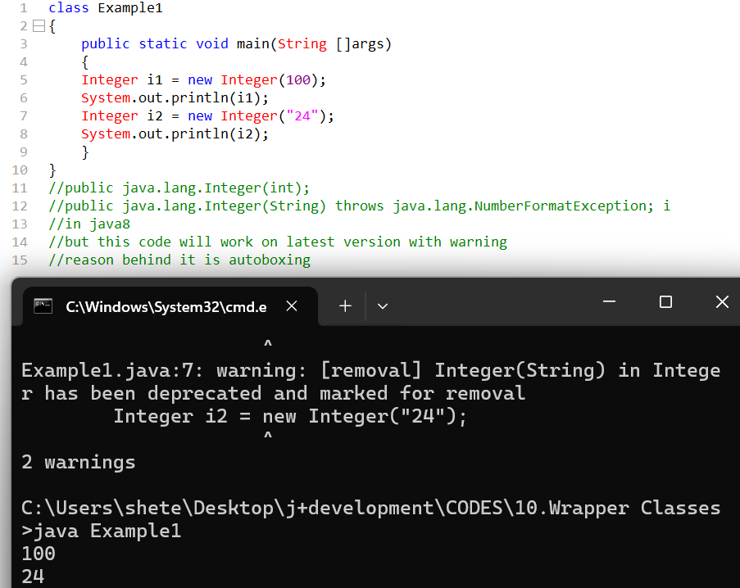

How do we convert primitive data in the form of object.
There are two methods to convert primitives into wrapper classes.

1.Constructor Based Approach
Whenever we print reference variable of wrapper class it will always print value not the address because to String () is overridden within all wrapper classes.
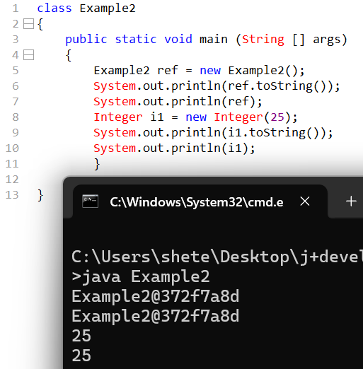

We get NumberFormatException when argument in “ “ passed are sequence of letters or characters.
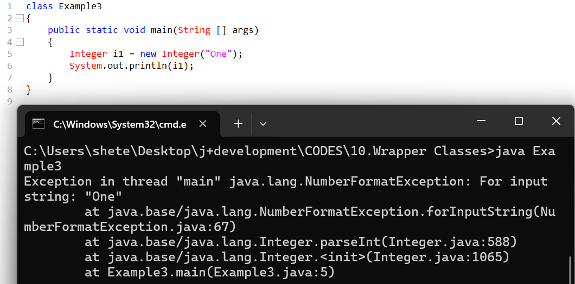

Which are minimum and maximum constructor within wrapper classes
Primitive | Wrapper Classes | Constructors
byte  short  int  long  float  double  char  boolean | Byte  Short  Integer  Long  Float  Double  Character  Boolean | Byte, string  Short, string  Int, string  Long, string  Float, double, string  Double, string  Char  Boolean, string

Which wrapper class has max constructors
Float
Which Wrapper class has min constructors
Chars
Object

Number
Character
Boolean

Double
Float
Long
Integer
Short
Byte

All Wrapper classes come under immutable nature
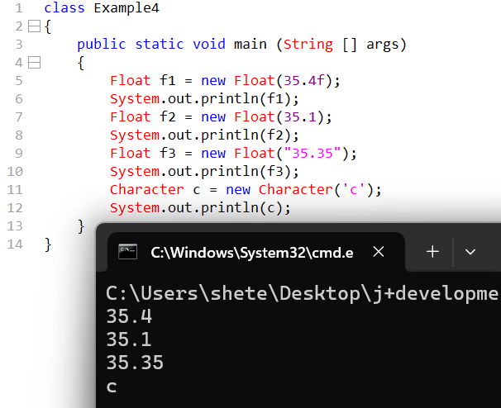
IMP methods within wrapper classes
The to String () is overridden in all wrapper classes, hence it will be not be responsible to print address but it will be responsible to print value.

Value of method
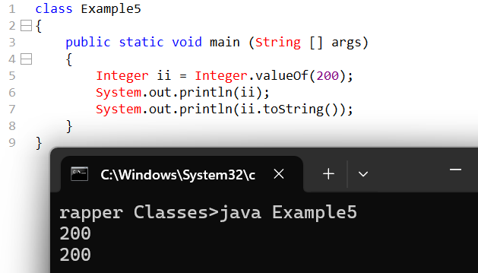
The value of method is responsible to return same class object such method are called as factory method

How do we convert wrapper object into primitive.
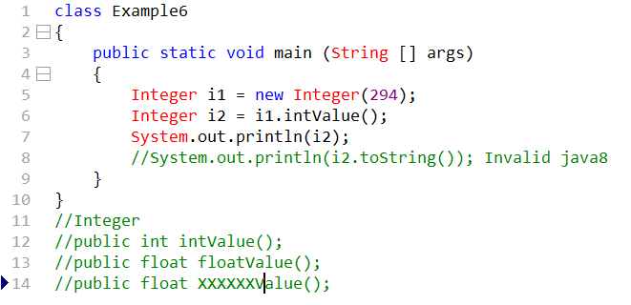
Boxing and unboxing operation
Converting directly a primitive data in the form of the wrapper objects is called as Boxing operation

Unboxing operations
Directly converting a wrapper object to primitive type such a process is called as unboxing
IMP note
This boxing and unboxing feature is by default use in collections which makes collection more stronger

Inner Classes(Nested clases)
A class within a class is called as inner class
Java does support the concept of inner classes but java does not support the concept of inner methods

Class Demo
{
Class SAMPLE
{}
}
= Supported

Void m1()
{
Void m2()
{}
}
= Not Supported

When do we prefer inner classes
Whenever there is inter dependency between features and classes we go for inner class
For one time usage of the classes we go for inner classes

Inner classes can be categorized mainly into two types
1.Static inner class
2.Non static inner class
2.1 Normal inner class
2.2 Method local inner class
2.3 Anonymous class

Normal Inner Class
- Whenever we compile a java program regardless whether it is normal class or inner class it will generate a .class file
- Whenever inner class .class file is generated, it will contain a $ symbol which will involve the names of outer class as well as inner class
- The outer class members can be accessed within the inner class
- But inner class members cannot be accessed directly within the outer class
- To access the inner class member in outer class it is not possible directly but we can access with help of object creation.0

5
We can access private members within the inner class
It is possible to access private members in the outer class.
To access the inner class object address we use this keyword but to access outer class instance variable when both the variable names are same in such a situation we go for outer.this

8
Even when method names are same in the inner and outer class we can use the approach of outer.this
It is possible to access static and non static members from the outer class to the inner class we cannot declare static members within the inner class as by nature the inner classes are non static .
9
It is possible to extend the inner class to the outer class by using extends keyword

Method local Inner Classes
A class declared or created within a method such a class is called as method local inner class
When the method is called within the stack only then the following steps can be implemented
- The class can be declared and the object can be created.
- With the help of object we can make changes to the respective class members.
- Once the method leaves the stack the object will be also eligible for destruction.

Whenever we compile method local inner class in java
It will generate .class file and in that .class file a numeric 1 will be added.
Outer$.1inner.class
12.java
If there are two different method having the same name of the inner class
Java will create two .class files as mentioned below
Outer$.1inner.class
Outer$.2inner.class

Static Inner class
13
- The static keyword is not applicable to the regular class but it is applicable to the inner class.
14
- It is possible to access static members of the outer class within the inner class
15
- In static inner class we cannot access the non-static member of the outer class within the inner class directly the only way to access them is by creating an object
16
- It is not possible to access directly inner class members in the outer class directly but it is possible to access inner class members into outer class with the help of object creation.
17

Anonyms Classes (Nameless classes)
- Anonyms classes are also called as nameless classes.
- Anonyms class helps to partially reduce the code length.
18
- As seen in example 18 it does not matter in which class you are implementing the methods hence the implementations can occur in any of the classes.

19
- Unknown classes or anonyms classes means we as a developer or automation tester may not give the name but internally the compiler may give the name such classes are technically called as Anonyms classes.
- Line 7 – this line performs multiple actions like – 1. It will represent the anonyms class representation with the parent class sample.
2.It is also responsible to load the anonyms class object creation in the memory and store the reference in s.
3. The respective line does not represent the object creation of the abstract class.
20

//30-31 nov

